URL Structure: https://adityabirlahospital.com/blogs/
Meta Title: Hand, Foot & Mouth Disease (HFMD) | Aditya Birla Memorial Hospital
Meta Description: Hand, Foot & Mouth Disease (HFMD) explained with key symptoms, causes, transmission, diagnosis, treatment steps, and prevention tips to reduce spread.
H1: Hand, Foot & Mouth Disease (HFMD): Symptoms & Causes

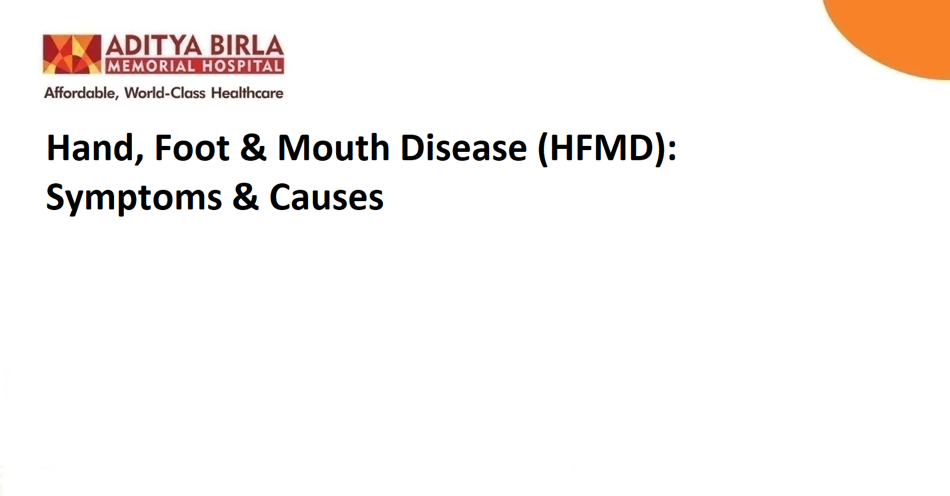

Introduction
Hand, Foot, and Mouth Disease (HFMD) is a common childhood infection that can worry parents due to fever, rashes, and painful mouth blisters. While it mostly affects young children, adults can get it too. The infection spreads quickly in schools and daycare centres, which is why understanding its symptoms, causes, and prevention is important. Early care and hygiene play a key role in ensuring a smooth recovery and stopping the infection from spreading to others.

What Is Hand, Foot, and Mouth Disease (HFMD)?
HFMD is a viral infection mainly affecting babies and children under 5 years of age. However, older kids and adults can also catch it. It is caused by the hand-foot-mouth virus, which is commonly a Coxsackievirus.
This illness is known for three key symptoms:
- Sores inside the mouth
- Rash on the hands and feet
- Fever in the early stage
Although it may look alarming, HFMD is usually mild and clears on its own within a week.

Causes and Transmission of HFMD

What causes hand, foot and mouth disease?
HFMD spreads through viruses that live in an infected person’s:
- Saliva
- Nose mucus
- Fluid from blisters
- Stool (poop)
Children often catch it by:
- Touching contaminated surfaces like toys, tables, or door handles
- Sharing food or utensils
- Close contact, like hugging or playing together
The infection spreads fastest in schools and childcare centres where kids are in close contact. HFMD is highly contagious, especially during the first week.

Recognising the Symptoms of HFMD
Symptoms usually appear 3–6 days after exposure. Common hand, foot, and mouth symptoms include:
- Fever
- Sore throat and irritability
- Pain while swallowing
- Mouth ulcers or blisters
- Rash on palms, soles, knees, elbows, or buttocks
- Reduced appetite
- Tiredness
- Sometimes, abdominal pain in kids
The hand, foot, and mouth rash looks like small red bumps, sometimes filled with fluid. It may be itchy or painful, but it usually heals without scarring.

Diagnosis and When to See a Doctor
Doctors diagnose HFMD by examining mouth sores and a skin rash and asking about symptoms. A lab test is rarely required unless symptoms look unusual.
See a doctor immediately if your child has:
- Trouble drinking fluids
- Dry lips or no tears (signs of dehydration)
- Very high fever lasting more than 3 days
- Severe headache or stiff neck
- Weakness or breathing problems
- Persistent vomiting
- Rash that becomes painful or infected
Though rare, complications like dehydration or viral meningitis can occur, so medical attention is key if symptoms get worse.

Treatment and Care for HFMD
There is no specific treatment for hand, foot, and mouth disease that kills the virus. The body fights it naturally within 7–10 days.
At-home care includes:
- Plenty of fluids (avoid citrus as mouth sores may hurt)
- Soft foods like soups, rice, and yoghurt
- Ice chips or cold milkshakes for relief
- Paracetamol for fever and discomfort (avoid aspirin in children)
- Hydration to avoid dehydration
Avoid: spicy food, chips, hard foods, and acidic drinks.
If symptoms worsen or the child cannot eat, a doctor may suggest medication to help reduce pain and prevent infection of sores.

Prevention: Minimising Spread of HFMD
HFMD spreads fast, but good hygiene can limit infections.
- Wash your hands often with soap
- Disinfect toys and shared surfaces
- Teach children not to touch their eyes, nose, or mouth
- Cover your mouth while coughing or sneezing
- Avoid sending sick children to school
- Do not share cups, bottles, or utensils
Good hygiene helps reduce hand-foot-mouth disease cases and stops outbreaks.

Conclusion
Hand, Foot, and Mouth Disease is common and highly contagious, but it usually clears without complications with proper care and rest. If symptoms become severe, medical support is important to prevent dehydration and other risks. Understanding how HFMD spreads and keeping strong hygiene habits can help protect young children and families from infection.
For expert evaluation and care from experienced infectious diseases physicians, consult the team at the best infectious diseases hospital in Pimpri Chinchwad.

FAQs

1. What is hand, foot and mouth disease (HFMD), and who is at risk?
HFMD is a viral infection mostly affecting children under 5, but older kids and adults can get it too.

2. Is hand, foot, and mouth disease (HFMD) contagious?
Yes, HFMD spreads easily through saliva, mucus, stool, and contact with contaminated surfaces.

3. How long does this disease last?
Most children recover in 7–10 days.

4. Can adults get hand, foot, and mouth disease?
Yes, adults can get HFMD, especially if they are in close contact with infected children.

5. What does an HFMD rash look like?
Small red bumps or fluid-filled blisters on hands, feet, and inside the mouth.

6. Is there a vaccine for HFMD disease?
Currently, there is no vaccine for HFMD. Hygiene and prevention measures are the best defence.

